Explaining Process Architecture and Lifecycle
Objectives
After completing this lesson, you will be able to:
- Understand the lifecycle of business processes.
- Explain the process of defining process levels and their architecture.
- Understand the value of visualizing business processes.
Process Lifecycle and Architecture
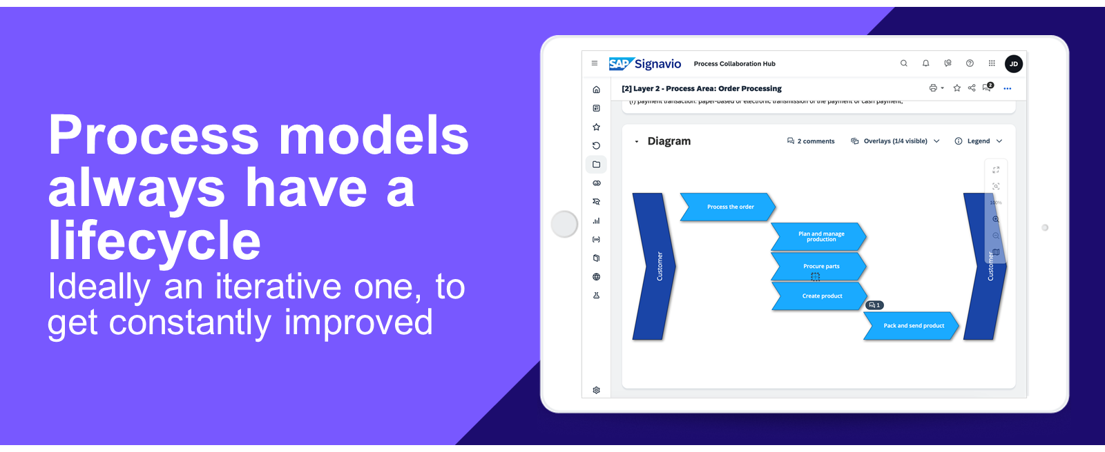
Process Lifecycle
Process Models are created to be viewed and executed by other people. Hence, every process follows an iterative lifecycle, which usually starts with documentation.
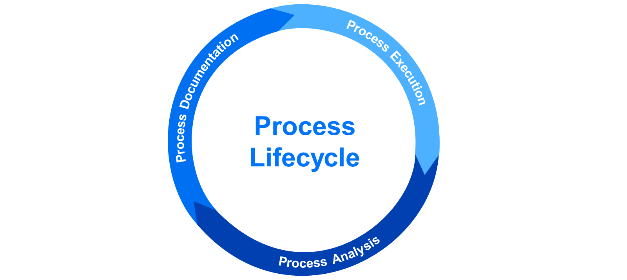
Process Documentation
Starts with capturing the fundamental process information.
- Running workshops with process participants
- Creating process-related surveys
- Conducting process interviews
The result of this phase should be a (new or refined) process model, which can be used as a common base for process execution - either by systems or manually.
Process Execution
Process execution means, people and /or applications using the process model to execute the documented business tasks. In a more automated way, workflow engines execute, control and govern tasks. These tasks in a process model can be actually assigned to users, who also get notified about open tasks in order to complete them on time
Process Analysis
Process Analysis is focused on setting process KPls in order to discover weak points, bottlenecks and /or compliance issues.
Example KPIs for a sales process could be:
- Number of new sales contracts
- Value of new contracts signed per period
Process Architecture Example
High-level value chains are quite common today as a starting point for organizations.
They help to structure, organize and control the business processes of the whole company and allow to drill-down into separate business areas to determine the final processes.
Note
Value chains are just one concept to provide an entry point to processes. Sometimes, companies also use modern navigation maps, traditional organizational charts or customer journey maps in order to link to respective processes.
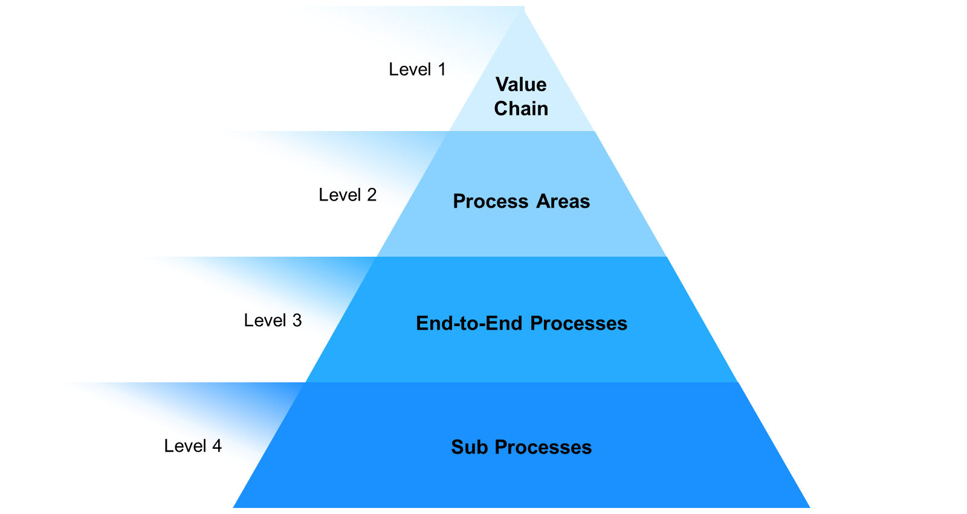
Value Chain
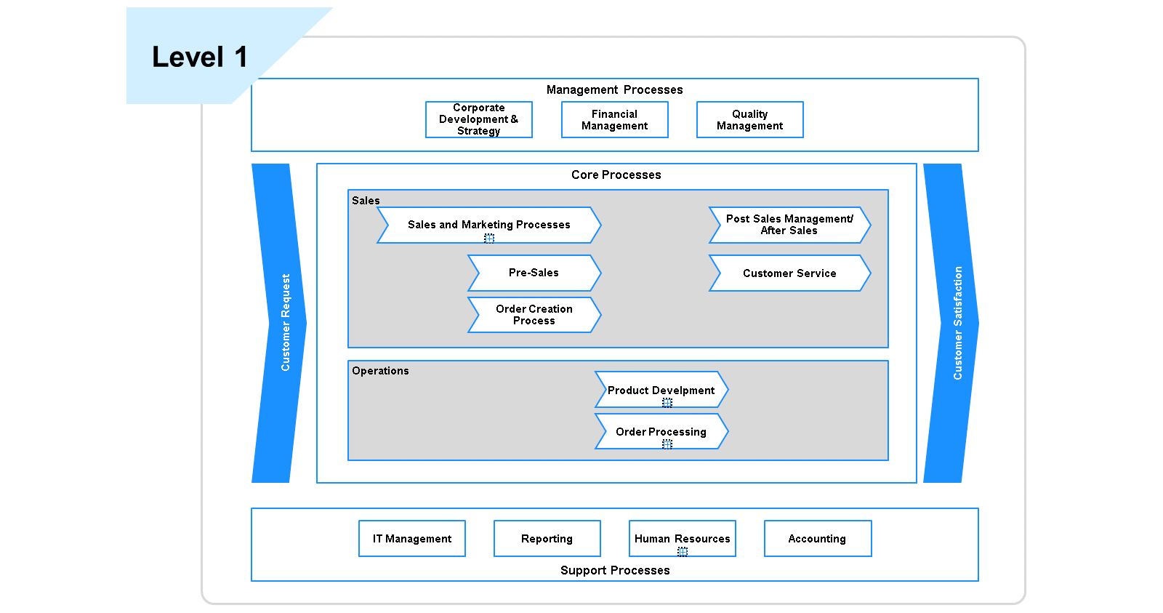
Value Chain models represent the process architecture of an organization from the highest standing point. A level 1 process landscape normally visualizes the process groups of management, core, and support processes, which are aligned to the overall company goals and strategy. An example would be the high-level overview of a company's business areas.
Process Areas
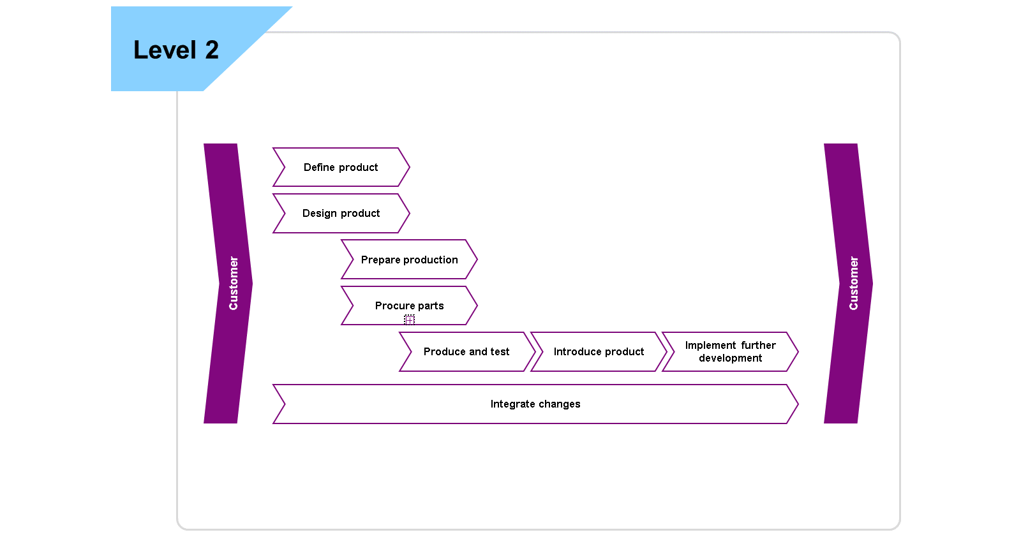
A particular process area focuses on a functional part of the organization, e.g. Human Resource, Finance, or Sales Department, and provides an insight into the corresponding business processes. It consists of a logical grouping of related process areas of a certain business unit.
End-to-End Processes
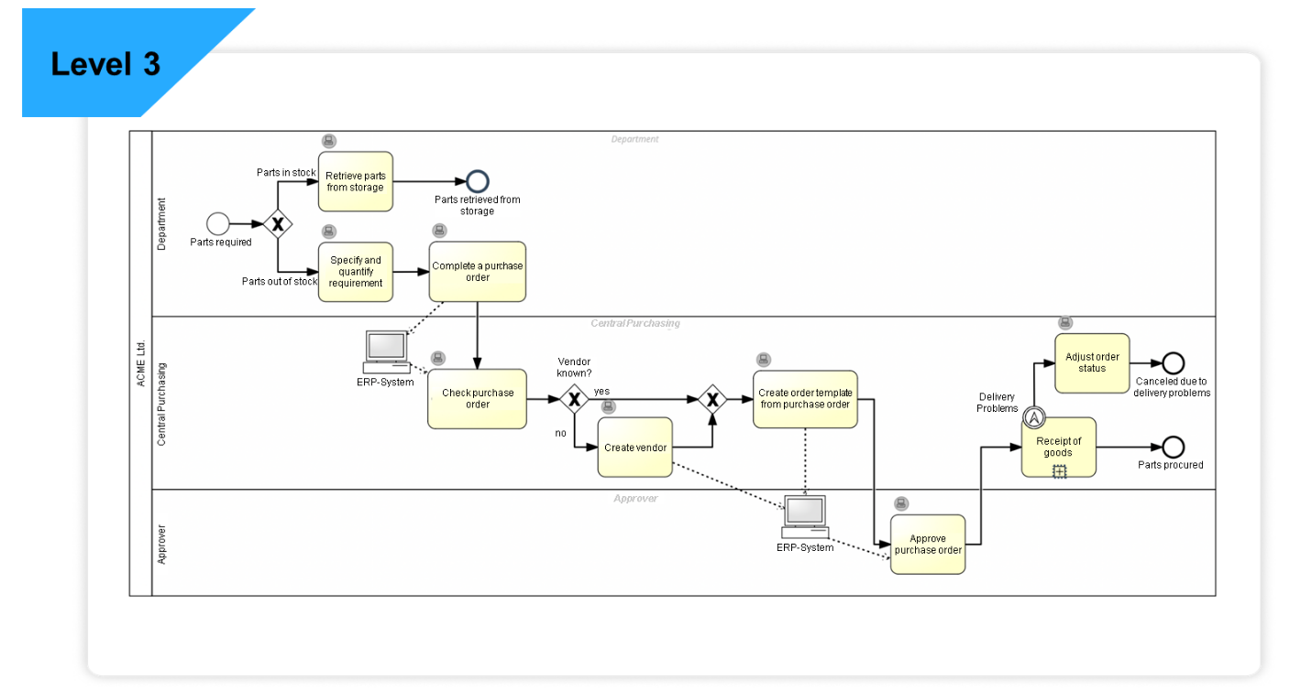
The third level of the process architecture is distinguished by existing and conceptual end-to-end processes of a dedicated process area. The BPMN is used for the graphical representation of all business processes. It contains the tasks, branches, and decisions to complete the process.
Sub-Processes
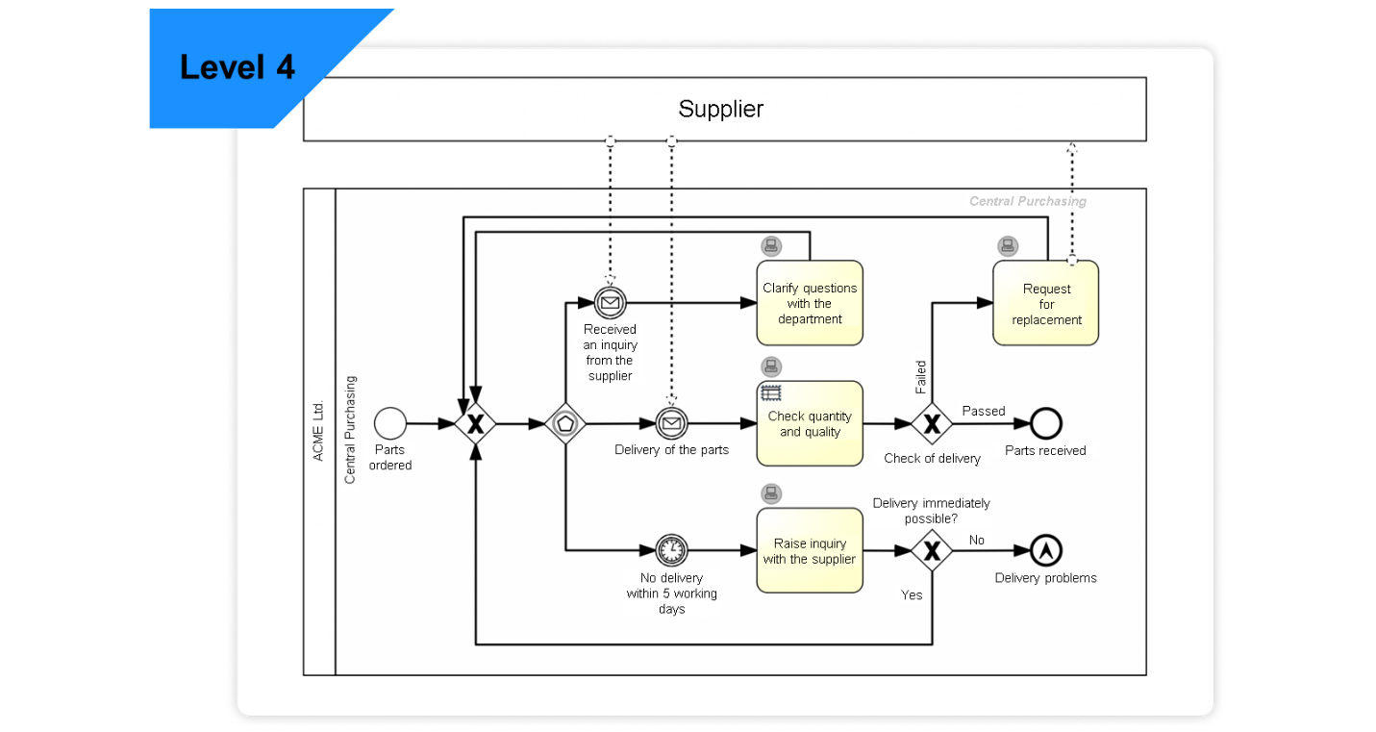
Further level of details and outsourced process information can be covered by sub-processes in the form of BPMN models that are linked to a single or even multiple main processes on the upper level of the process hierarchy.
Number of Levels in the Architecture
The actual number of levels depends on the complexity of the business areas. Sometimes it's useful to create an additional level if a further grouping of related processes is required. Some companies also create intermediate layers that represent process variants from different locations or entities of a business. A recommended (and also often found) number of levels in a value chain is between 3 and 5.
Creating a High-level Entry Point (to Processes and Business Areas)
High level value chains can show the business related services across different areas. Here is an example of what such a value chain could look like.
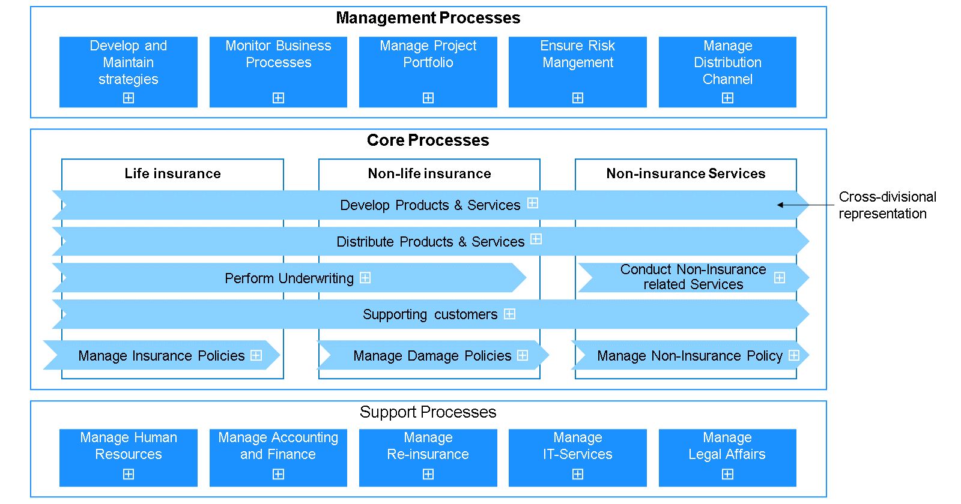
Subject-related Navigation
An entry point to processes and business areas can also be provided by a specific navigation map including clickable icons. Such an entry point can be aligned to product lifecycles, company / customer journeys or any other company specific journeys.
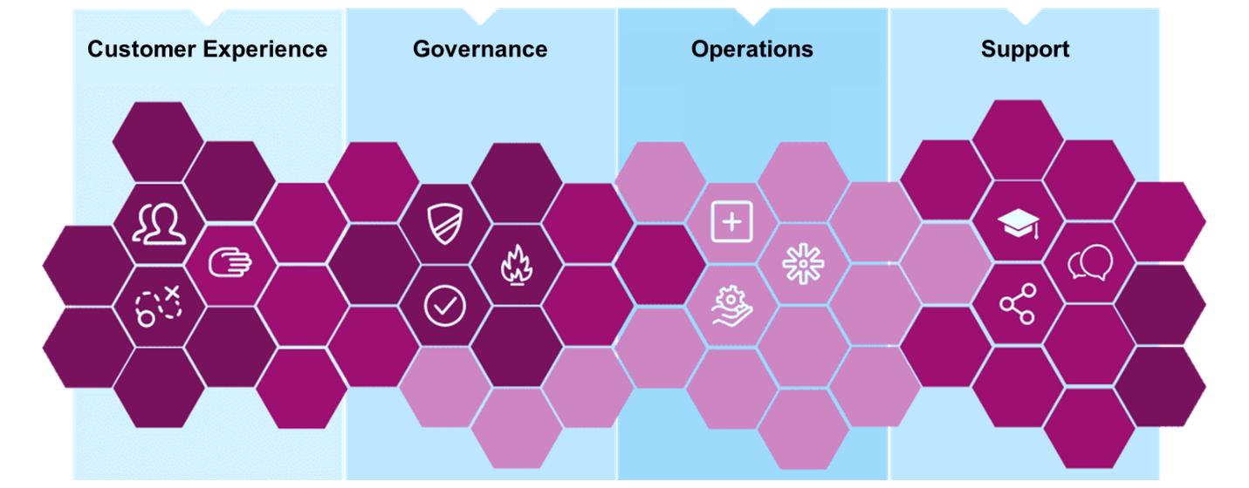
Customer Journeys (for Customer-related Processes)
Dedicated journeys allow linking to affected business processes, coming from the customer perspective. Behind each step, the corresponding business process could be linked.
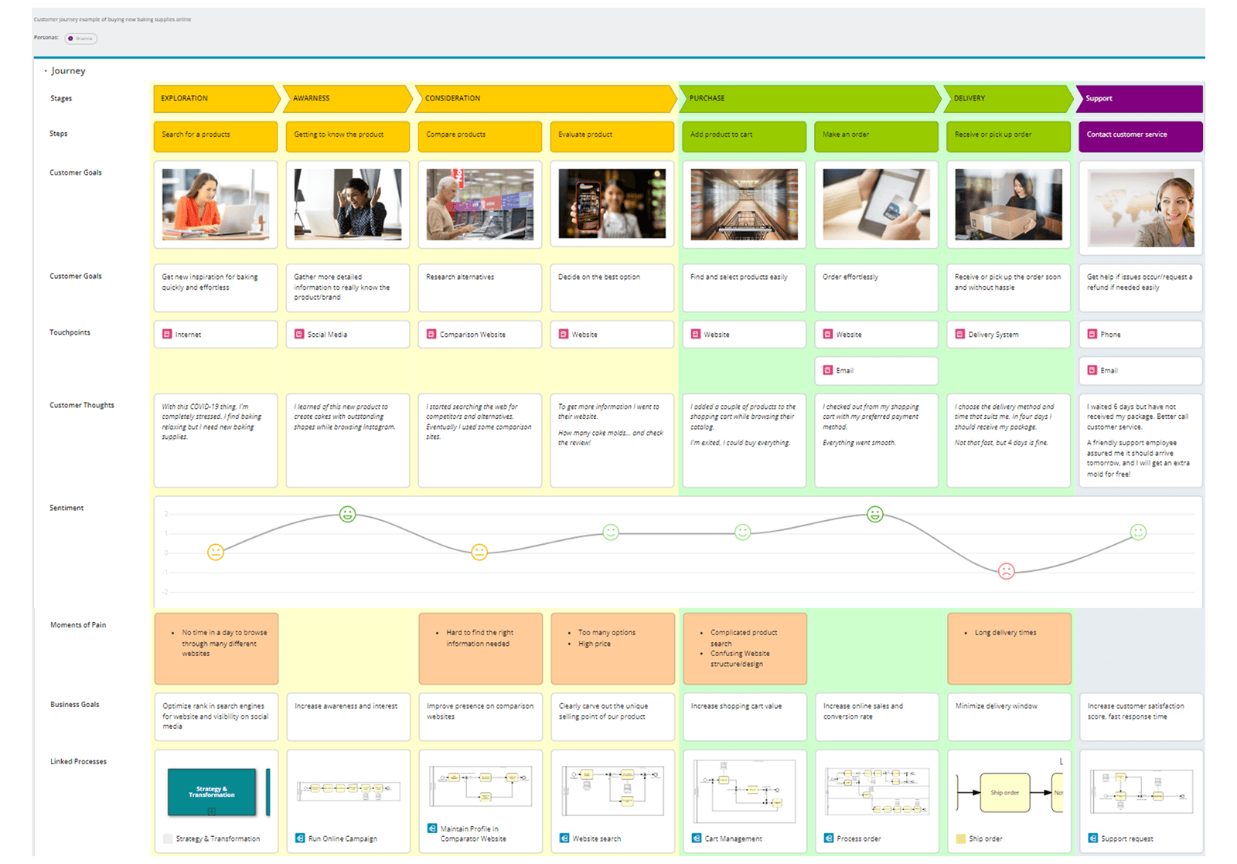
Note
To learn how to create a high-level entry point with a value chain or navigation map, please refer to the eLearning Introduction to SAP Signavio Process Manager. For customer journey maps please check out the eLearning Customer Journey Modeling.
Operational Business Processes
Do You Know Your Process?
Looking at the process levels, models can never show the entire complexity of the reality and this is also not intended. In a business context, the purpose of a process model is to provide an understanding of the process to all business users - and ideally enable them in executing the related business tasks.
Visualizing Business Processes
Process models provide information about business tasks, responsibilities and points of interactions. All internal employees should get a common understanding of the current process just by looking at the model and following the process flow. This is even more important for employees who are new to the organization for onboarding cases.
However, a created process model is the heart of every initiative - either for business improvement or for an IT Implementation.
Process Implementation
Process Documentation
- Modeling AS-IS processes
- Create transparency
- Share process knowledge
Process Design
- Modeling To-Be processes
- Process Simulation
- Assessment of alternatives
Process Analysis
- Problem diagnosis
- Cause study
- Potential estimation
Process Implementation
- Change Management
- Classic IT Projects
- Process Automation
Process Documentation - Making the Invisible Visible
Every process journey starts with documentation. More specifically, it starts with modeling the AS-IS situation in order to get an initial visual overview of the process. It doesn't matter how good or bad a process is at this stage - the only goal is, to make the process 'visible' in order to use this visual version as a basis for discussion / improvements. The captured BPMN diagram mainly provides information about individual process steps and the sequential flow of activities. Furthermore, it enables an understanding of process triggers and results, and even some decision points.
Firstly: Capture the Frame of the Process
The first activity is to capture the 'frame' of the process, which includes:
- Name: Does the process name reflect the purpose and content?
- Purpose: Does the process description include enough information, to provide a high-level understanding what the process is about?
- Goal: Is the described goal of the process reflected correctly in one sentence?
- Process owner: Who has the responsibility of the overall process and is interested in its successful execution? Who sets the KPI and is interested in its performance - and improvements?
- Additional process information: Are there any other additional information on process level?
Secondly: Add Additional Information Focused on Process Execution
The second activity is to add additional information, focused on process execution:
- Responsibilities: Which roles are involved for executing the tasks?
- Tasks and Descriptions: Which tasks are required? What information is required and needed to be provided in a dedicated task description?
- Systems: What tools or applications are used to complete the tasks?
- Data: What data or document are consumed or created?
- Risks and Controls: Are there any risks in certain tasks? Are the risks covered by corresponding controls?
- Key Performance Indicators (KPI): Which KPIs are suitable for the process to measure the performance?

